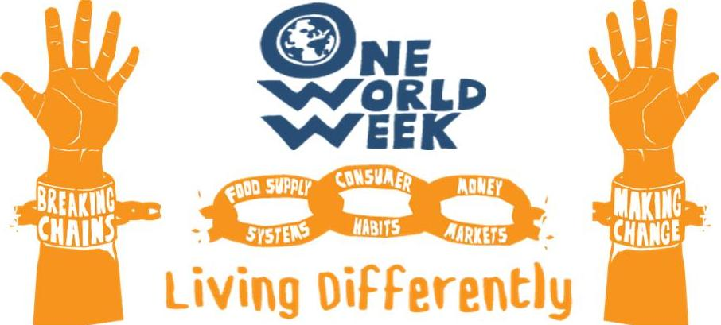
Breaking chains - Making change

QUOTATIONS

Introduction:

We have offered a few general quotes about ‘Living Differently’ and selections about:

food

wastefulness

money
How could you use these quotations?
- To stimulate thinking - you could select individual quotations, enlarge them and print them off – then put them in eye-catching positions around your event:

  - on tables if you are having a meal;
  - on seats for a presentation;
  - on the wall, if people are circulating;
  - include them in displays;
  - include appropriate ones in an interfaith event or worship;
  - give one to everyone as they come into the event. (Follow up by inviting them to sign up to a pledge later in the event or as they leave – see Sharing Destiny Pledges)
.
  - Make the concise ones into bookmarks, laminate them, let people choose in return for a donation.

- As part of your publicity – choose pithy arresting ones to catch the interest!

- As part of a discussion activity- give one to everyone or, if people are sitting round a table, let people choose one they like. Invite them to share it with the others and initiate a discussion about the implications for how we might change the way we live. You could use this together with the Sharing Destiny Pledges.

- Your ideas – we would love you to share your ideas about how to use quotations with other OWW organisers. Contact us and we’ll put them on the website.

The quotations
We found the following quotations from various sources, as indicated- from websites, publications and reports.
You will probably know lots more. Please tell us about your favourites – with sources if possible and we’ll include some of them on the website or use them to update this list.
Quotes about Living Differently

“The world we have created is a product of our thinking; it cannot be changed without changing our thinking.”
Albert Einstein

“When we are dreaming alone it is only a dream. When we are dreaming with others, it is the beginning of reality.”
Hélder Câmara

“We are faced with the “inconvenient truth” that current lifestyles cannot continue due to environmental limits, but the “convenient truth” is that working and consuming less can lead to increases in well-being.”
Dietz and O’Neill 2013, Enough is Enough. P.133

“We need to give each other the space to grow, to be ourselves, to exercise our diversity. We need to give each other space so that we may both give and receive such beautiful things as ideas, openness, dignity, joy, healing, and inclusion.”
- Max de Pree

“I slept and dreamt that life was joy. I awoke and saw that life was service. I acted and behold, service was joy.”
- Rabindranath Tagore

“Action springs not from thought, but from a readiness for responsibility.”

- Dietrich Bonhoeffer

“To know what is right and not do it is the worst cowardice.”
- Confucius

“We want to move together to a world that is our home, that is a garden. We are meant to live together harmoniously as members of one family, God’s family. There is only one race on earth, the human race, [we should] care for each other as members of a family.”

- Archbishop Desmond Tutu

“For good ideas and true innovation, you need human interaction, conflict, argument, debate”
Margaret Heffernan
Quotations about Food

“Earth provides enough to satisfy every man's need, but not every man's greed.”
- Mohandas K. Gandhi, quoted in E.F. Schumacher, Small Is Beautiful

The following three are quotes from Raj Patel’s ‘Stuffed and Starved’ 2012

“The global food system ... was engineered to create a world of increasing hunger and obesity.”
(preface to 2nd Edition of “Stuffed and Starved”, 2012)
“The current food system is a wasteland: it harms people and communities caught up in it, it engenders systematic cruelty to animals. It demands unsustainable levels of water and energy use. It contributes to global warming and provides fertile ground for disease.”

“Although controlled by some of the most powerful people on the planet, the food system itself is inherently weak. It is fragile because of the size of its ecological footprint, the resources needed to sustain it and the exploitation it requires.”
(Conclusion of “Stuffed and Starved”, 2012, p.300)

“Food sovereignty is the fundamental right of all peoples, nations and states to control
food and agricultural systems and policies, ensuring everyone has adequate, affordable,
nutritious and culturally appropriate food (…) Food sovereignty wrests control over our
commons back into the hands of the people.”
International peasant movement
La Via Campesina, Jakarta 2013

“The hardest thing is to take less when you can get more”.
- Kin Hubbard

“We must build our food policy on our own resources as is done in the other regions of the world. The G8 and the G20 can in no way be considered the appropriate fora for decisions of this nature”
Mamadou Cissokho, honorary president of the
West African farmers’ organisation, ROPPA

“Women farmers have few resources and do not want seed that we can plant for one season only or seed that is owned by companies. We believe in our own seeds that we can access from our own collections or from our farmer networks, free of charge.”

Beatrice Katsigazi, Eastern and Southern
Africa Small-Scale Farmers’ Forum
Quotations about wastefulness
“The degradation of natural systems owing to excessive consumption and misuse of natural resources as well as failure to establish an appropriate economic order among peoples and among states leads to the breakdown of the economic, social and political framework of civilisation.”
- Mawil Izzi Dien: The Environmental Dimensions of Islam

"Eat and drink, but waste not by excess, for God loves not the wasters" - Qur'an 7:31

“ ‘Make not thy hand tied to thy neck, nor stretch it forth to its utmost reach, so that thou become blameworthy and destitute.’ (- Qur’an 17:29) Don’t put your hand so close to your neck, a symbol of being too stingy, and overextend it, a symbol of wastefulness and extravagance.”
- Jamal Badawi: Economic system of Islamic consumption

“We must move away from the relentless pursuit of economic growth and wealth, to the well-being of people and planet. This means a radical change from our unequal and wasteful lifestyle. Ethics before Economics.”
- Bishop Geoff Davies (Executive Director,
Southern African Faith Communities’ Environment Institute.

“The model of ownership, in a society organized round mass consumption, is addiction.”
Christopher Lasch (American historian, moralist, and social critic)

The following two are from Tim Jackson – a key thinker about alternatives to our current economic growth model, writing in a report ‘ Motivating Sustainable Consumption’ in 2005

“Consumer behaviour is key to the impact that society has on the environment.”

“Far from being able to exercise deliberative choice about what to consume and what not to consume, for much of the time people find themselves ‘locked in’ to unsustainable consumption patterns.”

"In this day and age throwing food away is madness, especially when some don't have enough to eat. This is why I am proud to be supporting FoodCycle, such an important project whose focus is to limit the amount of food waste and tackle food poverty"
Giorgio Locatelli

“With so much evidence of depleting natural resources, toxic waste, climate change, irreparable harm to our food chain and rapidly increasing instances of natural disasters, why do we keep perpetuating the problem? Why do we continue marching at the same alarming beat?”
Yehuda Berg

Quotations about:
using money to make the change we want to see

“ At present, we are stealing the future, selling it in the present, and calling it GDP.”
Full Quote: “At present, we are stealing the future, selling it in the present, and calling it GDP. We can just as easily have an economy that is based on healing the future instead of stealing it. Whenever we exploit the earth, we exploit people and cause untold suffering. Working for the earth is not a way to get rich, it is a way to be rich.” (Opening of the Commencement address at the University of Portland) (our emphasis,OWW)
—Paul Hawken 2009

“It makes no sense to invest in companies that undermine our future.”

- Archbishop Desmond Tutu

“ ‘In you they have taken bribes to shed blood; you have taken interest and profits, and you have injured your neighbours for gain by oppression, and you have forgotten Me,’ declares the Lord God.”
Ezekiel 22:12

"Be a community that calls for what is good, urges what is right, and forbids what is wrong: those who do this are the successful ones"
Qur’an 3:104

‘The best of you is he (or she) who is of most benefit to others’
Saying of Prophet Muhammad (peace be upon him)

“Our current monetary system is not capable of providing a high standard of living for everyone, nor can it ensure the protection of the environment because the major motive is profit.”
http://www.thevenusproject.com/about/the-venus-project

“Real reform needs to start with banking’s roots, not its branches ... to a fundamental change in their reason for being, serving society rather than themselves.”

Charles Middleton, Managing Director, Triodos Bank

“We only lend money to organisations whose work delivers environmental, social and cultural benefits.”
Triodos Bank, 2014

